GCP – Google Cloud Platform

It has about 200+ services

Web console – console – portal to manage many services provided by GCP



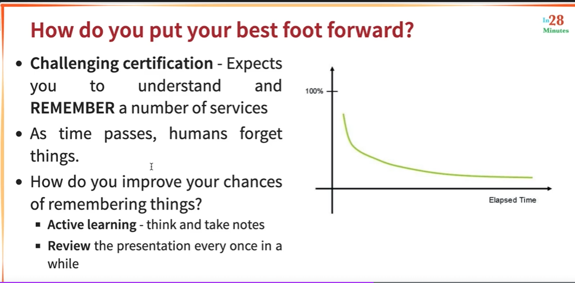

Command line utility – gcloud is important

What is cloud and why do you need cloud -

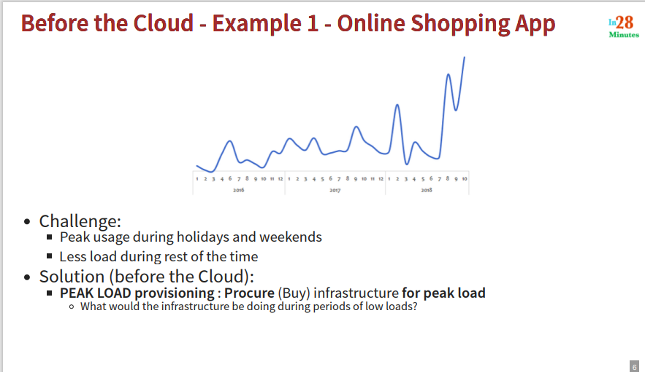

Consider online shopping application

Wastage of infrastructure during low load period

For a startup – lot of investment in HW – infrastructure. If not successful, HW/infrastructure is wasted.

Ahead of time planning, need to procure infrastructure, low infrastructure utilization during low load and need dedicated team to manage this infrastructure

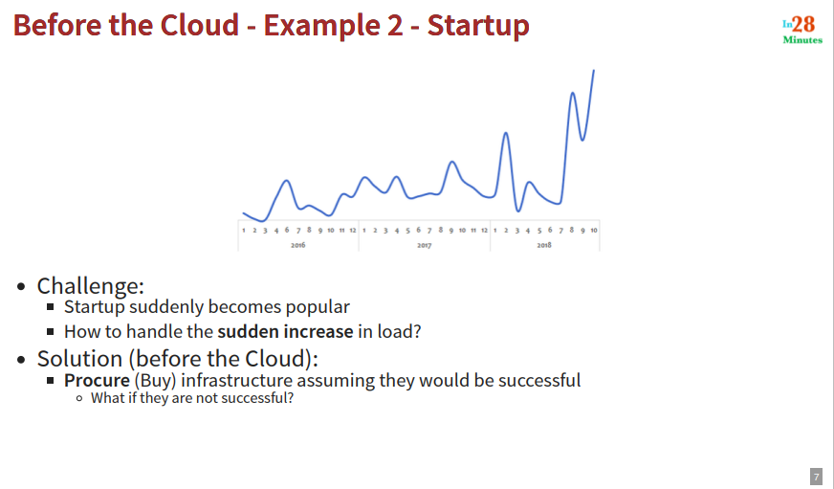

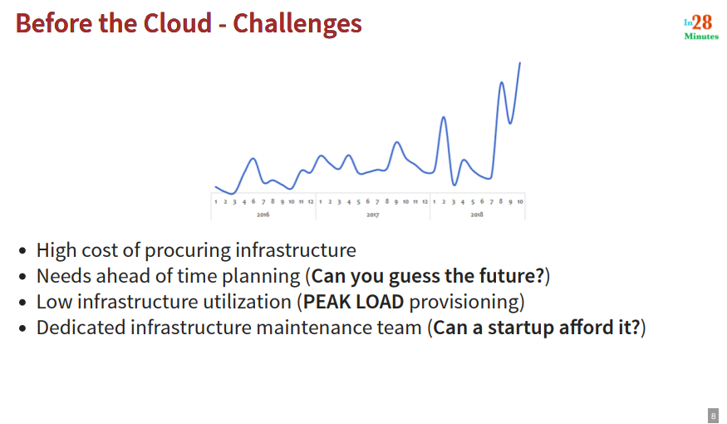

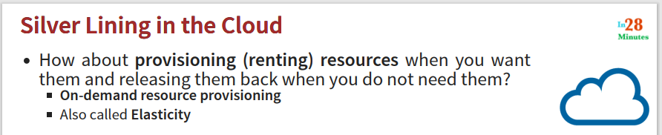

Advantages of such an approach:

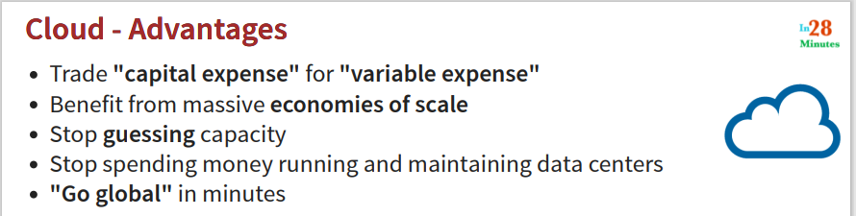

You can get best deal from various cloud providers – no need to guess capacity

You can go global – with a click of a button – startup in India an deploy in US

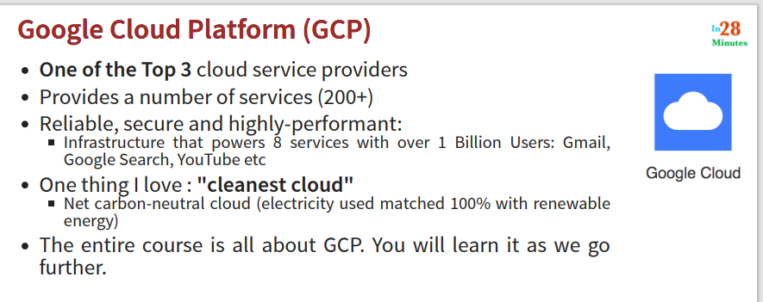

Azure, AWS, GCP

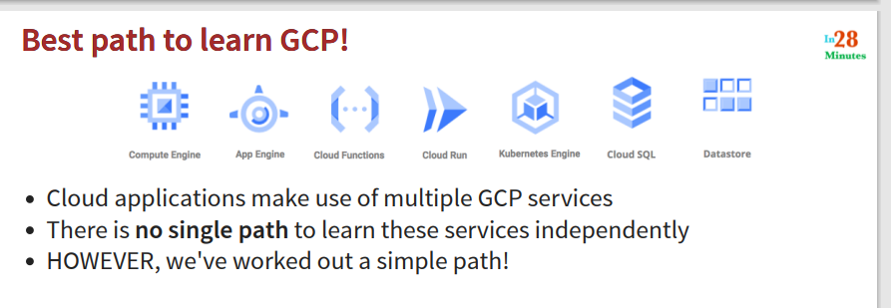

You cant learn the services independently, need to learn multiple services

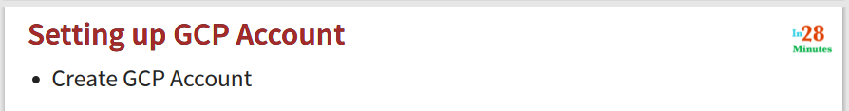

Free credit of 300$ - personal details and valid CC – 90 days

<https://cloud.google.com> – get started for free – country

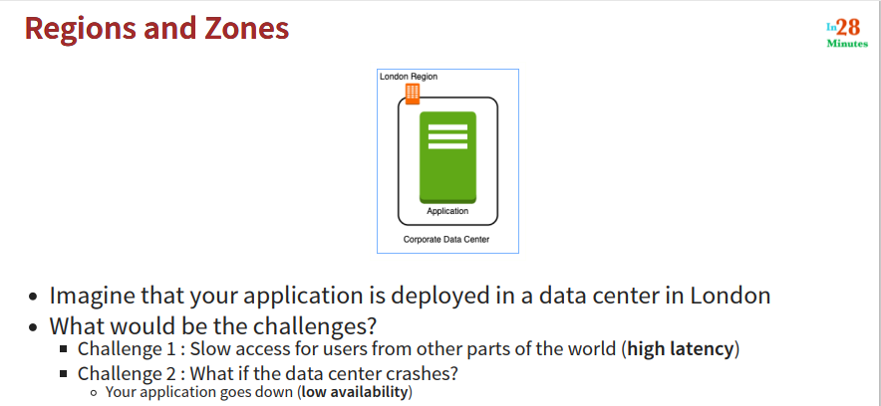

Users in Mumbai, New York – slow access – high latency

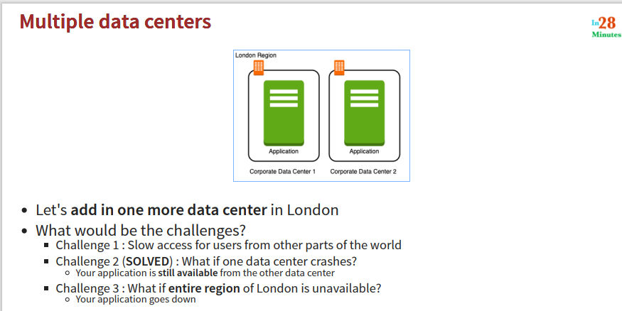

With this challenge 1 remains

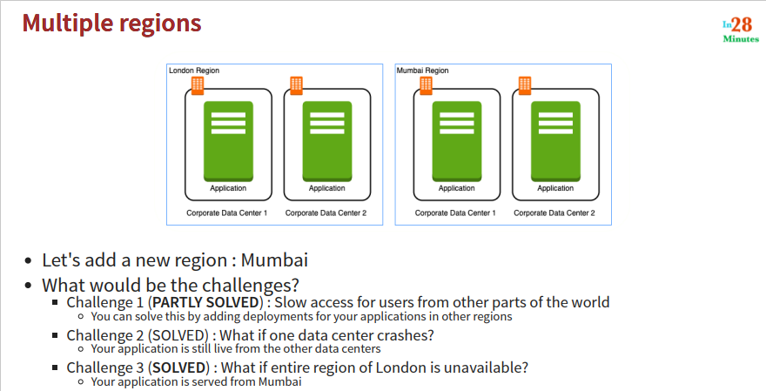

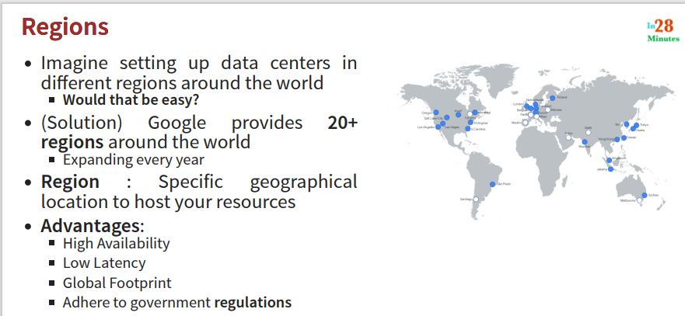

Setting up DC in different parts of world is not easy for an organization – Cloud Providers help here

Helps to setup Global applications

Data related to citizens can stay in particular geographical region

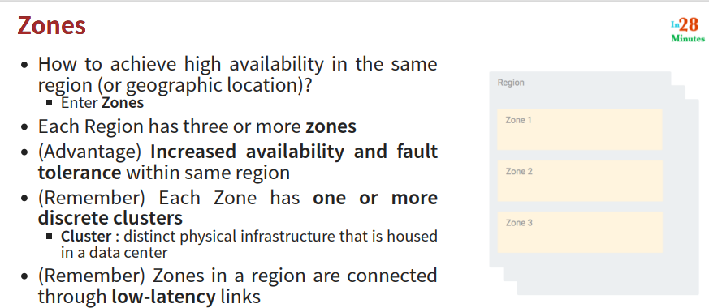

In one region to get high availability – use multiple zones for deployment

Cluster – data center

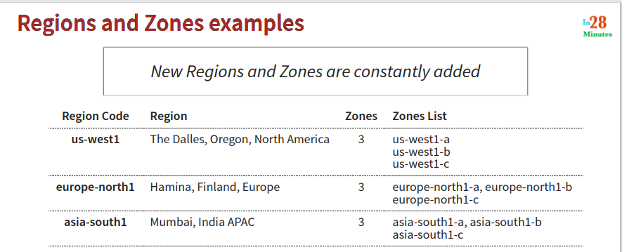

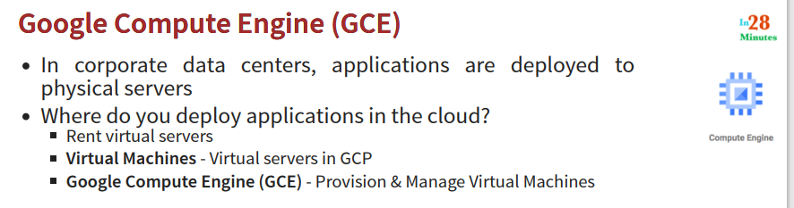

Helps you to create virtual machines in google cloud

Setting up a web server in GCP

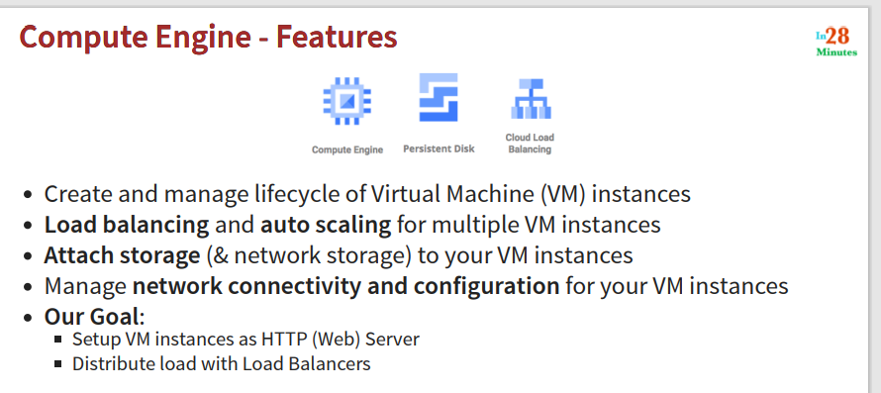

Enables you to provision virtual servers

Earlier – applications were deployed on physical machines, Now they are deployed on virtual servers – in cloud

Google cloud compute engine – allows you to create, start, stop, terminate, VMs, manage lifecycle of VMs

Distribute load between VMs, autoscaling

Attach storage, assign IP address,

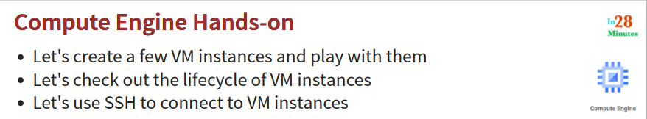

ssh and run a few commands

Go to google console, check project information, go to compute engine, Create

Provide name (my-first-vm), give label – environment: dev, business: sales (gives more info about VM)

Provide region, zone (can keep defaults)

Choose HW – machine configurations – we get some machine configuration families

Now choose OS (SW) – by choosing image (different images for different OS) (choose default - debian)

Firewall configuration – we want to run http server – so choose “Allow http traffic”

Click Create (you can check the cost of this VM – play with it and delete it)

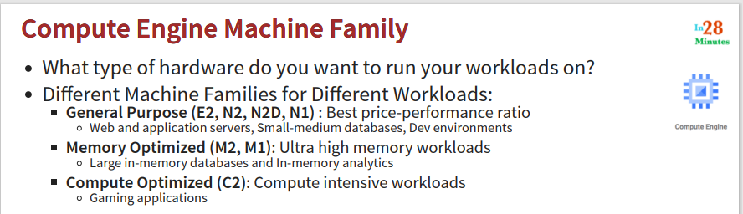

Need to consider Machine family – machine type

Based on type of application that you want to run decide machine family and then machine type within that family

Consider memory, disk, compute power you would need

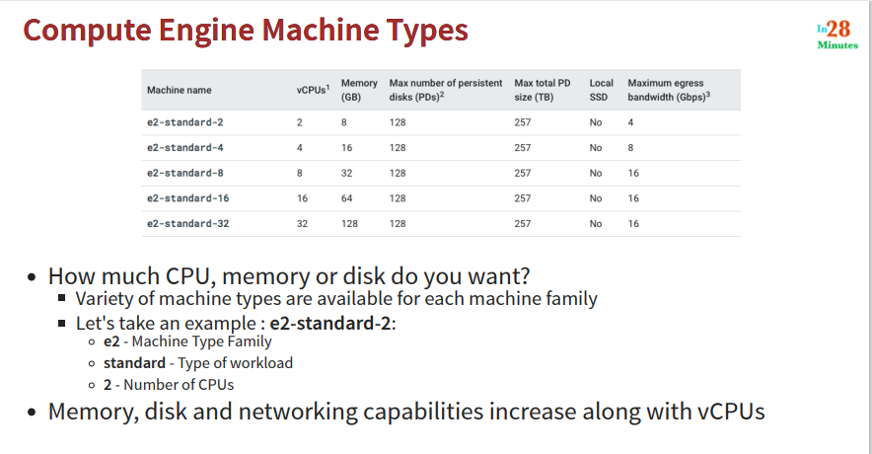

What image to use:

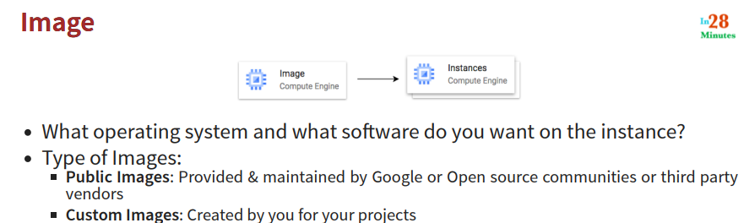

Monitor the VM you created – name, zone, internal IP, external IP

Suspend is like pause, reset is like restart

SSH into it and run a few commands – enable your browser popup (you can change color theme, text size)

Type some commands:

who am I, pwd, ls,

COMMANDS

1. sudo su
2. apt update
3. apt install apache2
4. ls /var/www/html
5. echo "Hello World!"
6. echo "Hello World!" > /var/www/html/index.html
7. echo $(hostname)
8. echo $(hostname -i)
9. echo "Hello World from $(hostname)"
10. echo "Hello World from $(hostname) $(hostname -i)"
11. echo "Hello world from $(hostname) $(hostname -i)" > /var/www/html/index.html
12. sudo service apache2 start

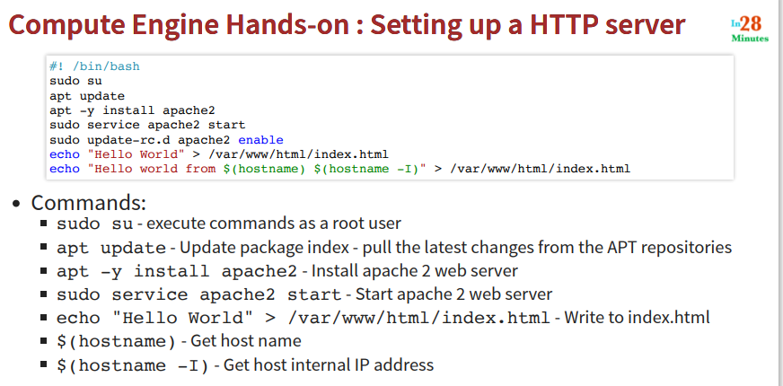

apt – package manager installed on debian by default

apache – http server that we want to run on the vm

click on the External IP – you should see the home page of apache

customize the page by writing something to the /var/www/html/index.html

Refresh and you should be able to see your content

Try to display hostname and IP address (internal IP address) on index page

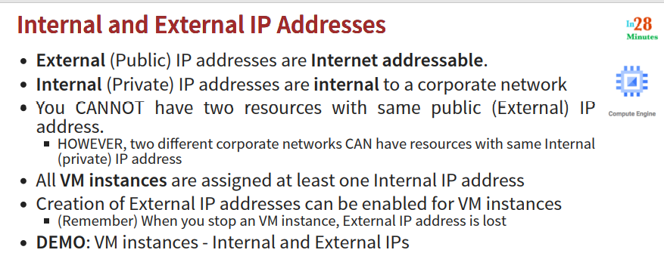

You can call external IP address from outside – internal IP address – inside the gcp network – can be used from within the gcp network

Two different corporate networks can have same internal IP address. By default at least one internal IP address is assigned.

External IP address is lost when you stop an instance. (you will see none in the External IP address column) – Internal IP address remains assigned

When you start – it gets external IP address – but a different one (if you refresh the browser page – you will get 404 error) ssh connection is also lost – ssh again with new external IP address. You need to start the apache service again when you start the vm

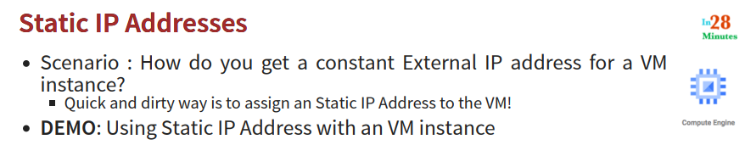

External IP address changes when you stop and start a VM – to solve this problem – use a static IP address (another solution is to use LB – seen later)

On gcp console – VPC > External IP addresses – you will see details of external IP addresses – you need to reserve static IP address – give it a name (my-first-static-ip-address) – choose NW (default) – IP address format (IP v4 IP v6) – regional or global type (region should be same as the region for your VM)

By default – IP address assigned to your VM is ephemeral – you can assign static IP address to your VM – VPC > External IP address > choose IP > change

Now stop and start and observe that the external IP address does not change (because now we assigned static IP address to our VM)

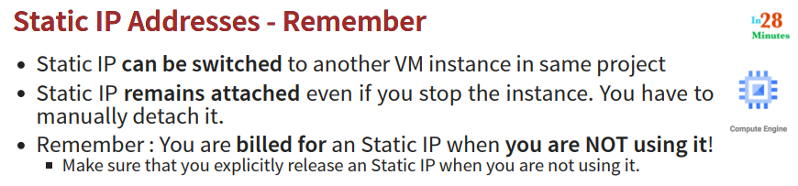

Static IP addresses can be switched from one VM to another but within the same project

Explicitly release when not in use

Here is the startup script we will use in the next step:

1. #!/bin/bash
2. apt update
3. apt -y install apache2
4. echo "Hello world from $(hostname) $(hostname -I)" > /var/www/html/index.html

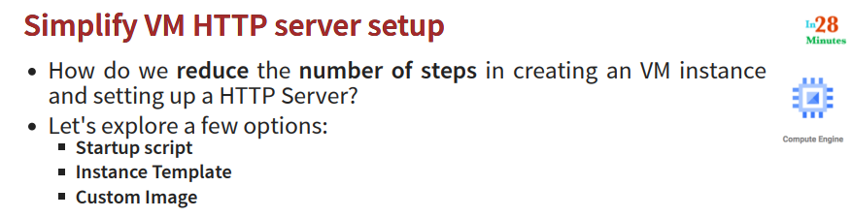

Run a script when your VM starts

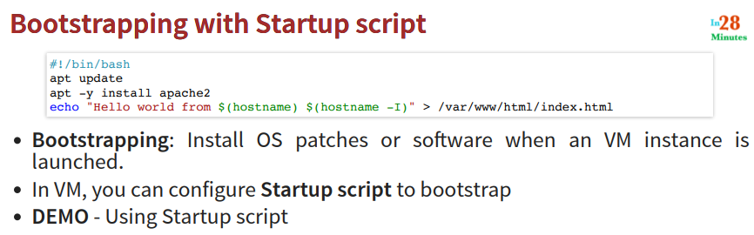

Bootstrapping – install all latest OS patches as part of startup script – which is run when your VM starts

Demo – create vm (my-vm-with-startup-script) – management > startup script > specify your startup script here (-y option to say yes when it prompts before install) – the vms gets created – startup script gets run – now access the VM using external IP address

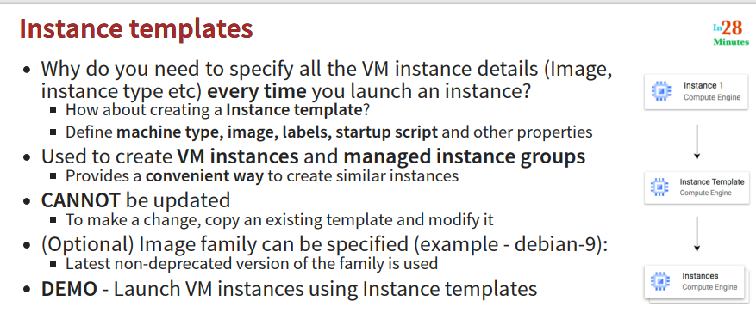

With startup scripts – after creating one VM with startup script, if I want to create another – need to again follow these steps

Better option is to create a template – later use this template

**Demo** – Compute Engine > Instance template > create new instance template > give name (my-instancetemplate-with-startupscript) – select other details (machine type > OS > NW)

To create instance – select instance template > create VM – name for the VM will be – template name – 1

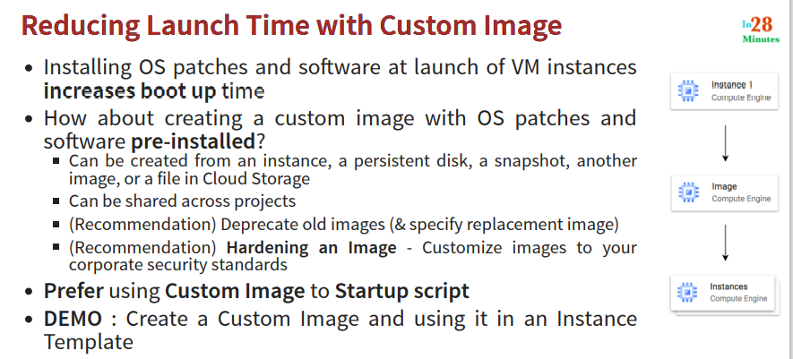

Drawback of start script and instance template – start up time (launch time) is more

Create custom image from your instance which already has required patches (startup script already run) – all corporate security standards can be followed – hardening images – image as per security standards

Old images can be marked deprecated

**Demo** – Compute Engine > Disks > (disk name for VM is same as VM name) > actions – create image > source will be Disk > choose location – regional or multi regional (default - multiregional)

There will be an error – you cannot create image from disk attached to a running instance

Stop the VM instance and try again – you can see the image in Compute Engine > Images – observe the name and status

You can create VM directly from this image – or create an instance template first using this image

Compute Engine > Instance Template > Create an Instance template > Change the boot disk (instead of public image, select custom image)

From this instance template, you can now create a VM instance. Confirm the following startup script

1. #!/bin/bash
2. apt update
3. apt -y install apache2
4. echo "Hello world from $(hostname) $(hostname -I)" > /var/www/html/index.html
5. service apache2 start

Troubleshooting steps:

Chk you are using External IP address > Apache is installed – service is running > verify content of index.html > ensure firewall setting of VM instance

Try pin option in the console – to pin frequently used services

Try Billing > monitoring > activity on console dashboard

Check Project option (Create new project option) – notifications- project settings

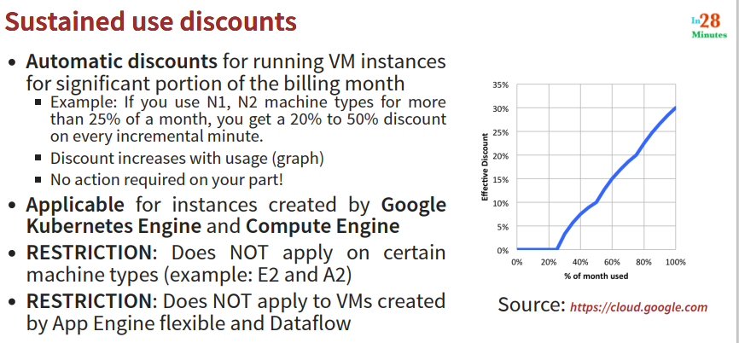

If you are using your VM for 80% of the time in a month more discount than you would get if you are using for 40% of the time

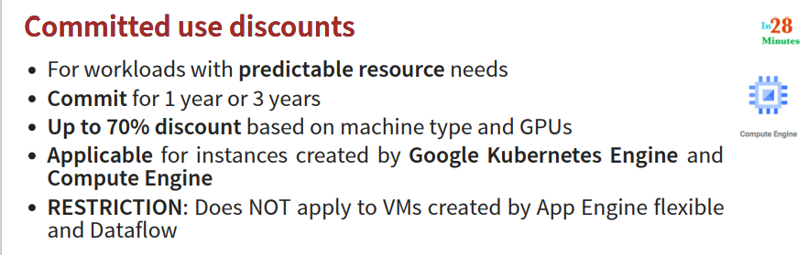

This needs a commitment from you – useful for predictable usage scenario – the committed use discount is higher than sustained use discount

How to ask for it – Compute Engine > last option (purchase commitment – specify the values – HW commitment/ SW, family, region, machine configuration)

If you know you are going to use your web application for a long time

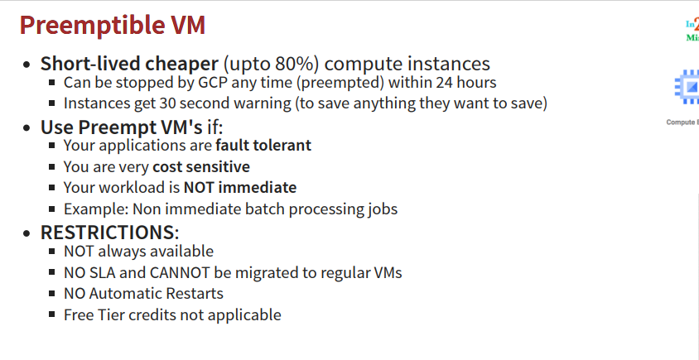

Something like spot instances in aws – gcp can terminate within 24 hours – gives 30 min warning

Converted convert it into a regular VM – cannot use it when we are using free credit (for 90 days) – costs much less but lasts for only 24 hours – very cheap compute instances

**Spot VMs**

Latest versions of pre-emptible VMs – does not have maximum run time – may be reclaimed by gcp with 30 seconds warning – NOT always available – Dynamic pricing – 60 – 90% discount as compared to on demand VMs – not applicable for free credit

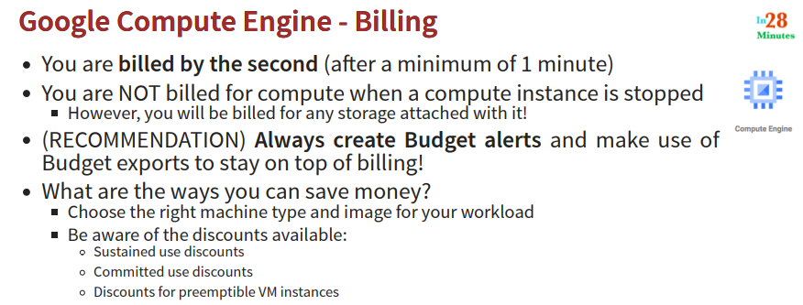

Minimum usage – 1 minute – you are billed for minimum 1 minute

Create budget and budget alerts Billing > Budget & Alerts – provide name and target amount – specify the thresholds

Billing export > export it to different resources

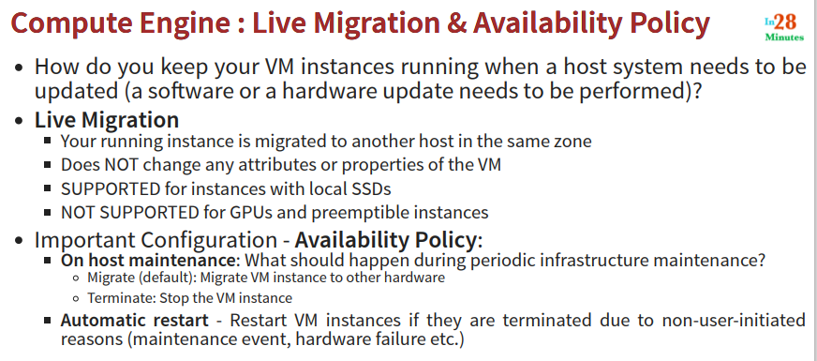

How to keep your VM running – when SW or HW update needs to be performed

Compute Engine provides LIVE migration

Configure it using – Availability Policy -While creating VM > Availability Policy

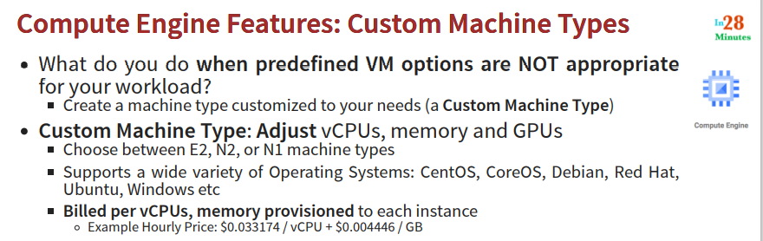

When predefined VM types not suitable for your requirement – but applicable for certain machine types only

Specify your requirements – while creating VMs – choose machine type as custom machine type – provide memory – number of vCPUs – number of GPUs

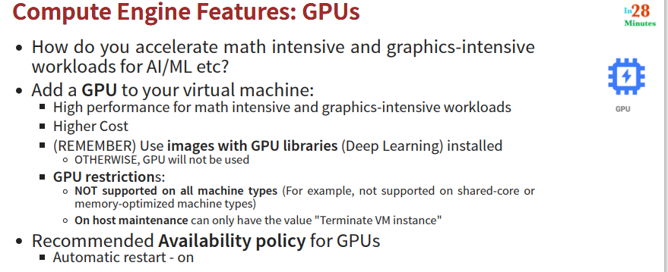

Important for performance – if your requirement is for high performance – cost will be high – you must have the required SWs – images with required libraries for GPU

Limitation – cannot do LIVE migration

How to create GPU – while creating VMs – select GPU specific machine family – or select any machine type and add GPU (not available for certain machine families)

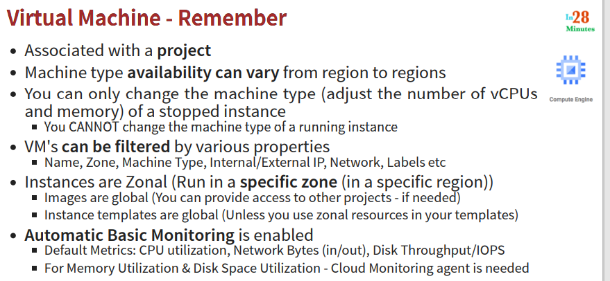

VM will always be associated with project - Project is to manage your resources

Try create new project – cannot change type of running VM – try to edit machine type of a running VM instance – stop it and try again – should be possible

Filter option available – name, zone, machine type, NW, labels, IPs

Instances are always in a zone and region – but images are global – instance templates are also global

**Demo** – View monitoring of a certain running VM (cloud monitoring agent required for certain monitoring)

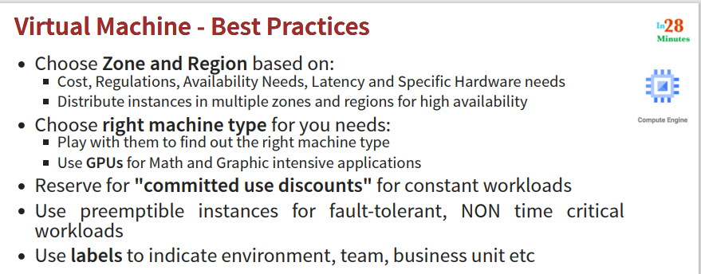

Check where your users are – accordingly choose region – depending on work load choose correct machine type – take care of cost – like committed use discount for web application

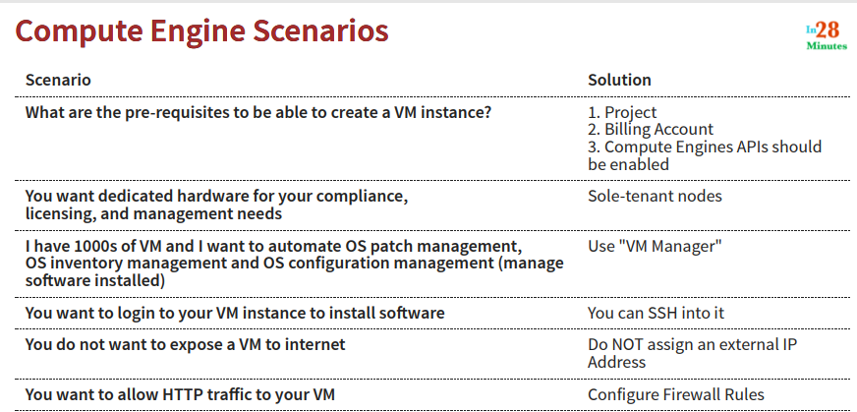

You need a project to start using GCP VMs - You pay for your resources using billing account – APIs should be enabled (search Compute Engine API – when you create a new project – it will not be enabled by default)

The HW will be shared – you may need dedicated HW – ask for it – using Sole tenant nodes (try this option) – need to create node template – configure auto scaling – group labels in lower case

When you create VM you can then select sole-tenancy (first create sole tenancy and then use it)

VM manager > OS patch management (for 1000s of VMs)

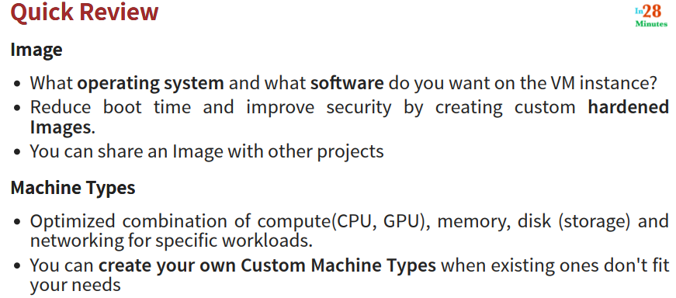

Custom Images can be shared with other projects

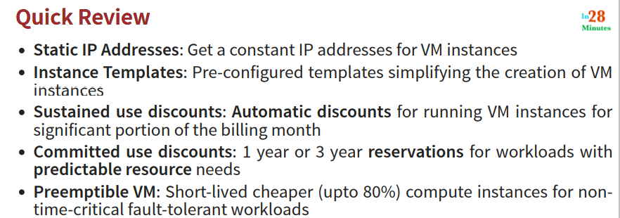

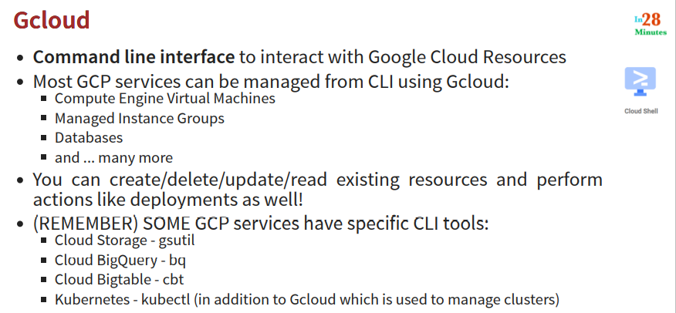

To interact with resources in gcp – use command line utility – gcloud – create, start, stop, delete resources

gcloud, bq, cbt, kubectl – different command utilities

gcloud – installed as part of google cloud sdk – free to use for all users

another approach to use gcloud – without installing google cloud sdk – can be accessed from console (cloud shell terminal session)

gcloud –version gives you version of gcloud installed, also lists different utilities installed

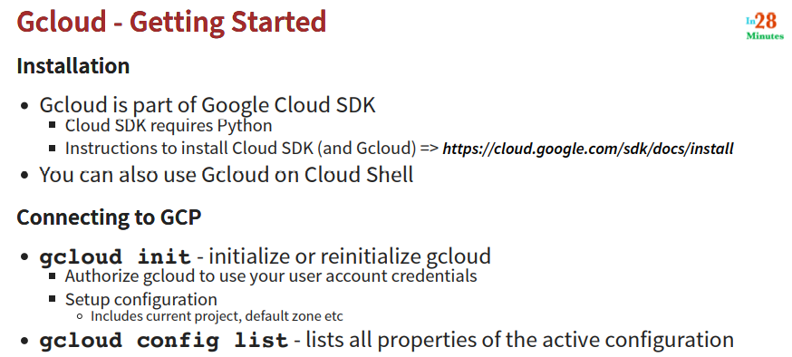

gcloud init – shows existing configuration, current project id etc, (each project gets globally unique id)

create a new configuration – choose different options – give name, account id, project id, region, zone, (this is only a local setting)

Region, zone, account, project – configuration to remember

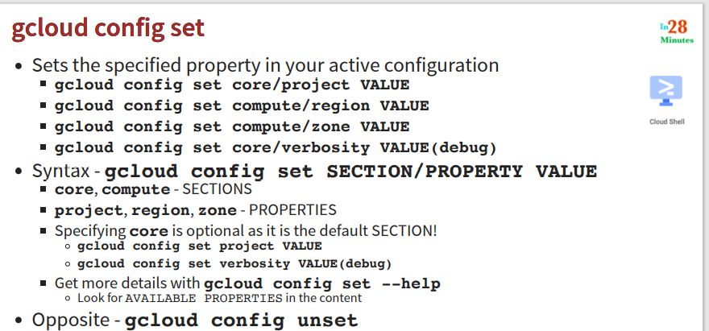

To change the values – gcloud config set

To get back to default – gcloud config unset

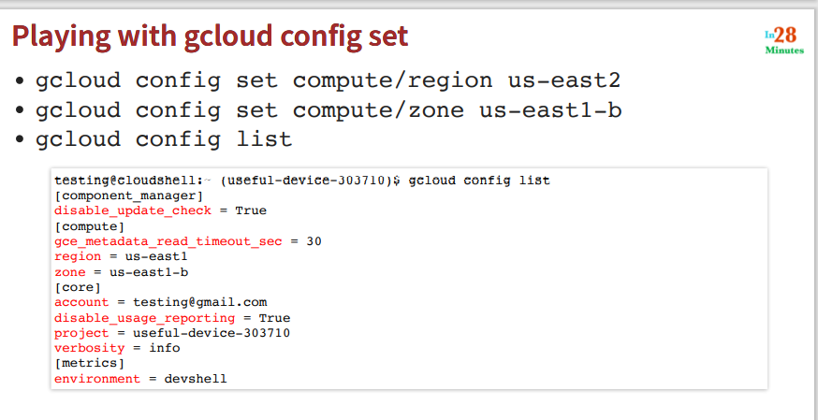

gcloud config list account

gcloud config list

**Commands executed in next steps**

Here are some of the commands we would execute in the next few steps:

You can refer back to this if you have problems. Good Luck.

1. gcloud config list project
2. gcloud config configurations list
3. gcloud config configurations activate my-default-configuration
4. gcloud config list
5. gcloud config configurations describe my-second-configuration
6. gcloud compute instances list
7. gcloud compute instances create
8. gcloud compute instances create my-first-instance-from-gcloud
9. gcloud compute instances describe my-first-instance-from-gcloud
10. gcloud compute instances delete my-first-instance-from-gcloud
11. gcloud compute zones list
12. gcloud compute regions list
13. gcloud compute machine-types list
15. gcloud compute machine-types list --filter zone:asia-southeast2-b
16. gcloud compute machine-types list --filter "zone:(asia-southeast2-b asia-southeast2-c)"
17. gcloud compute zones list --filter=region:us-west2
18. gcloud compute zones list --sort-by=region
19. gcloud compute zones list --sort-by=~region
20. gcloud compute zones list --uri
21. gcloud compute regions describe us-west4
23. gcloud compute instance-templates list
24. gcloud compute instance-templates create instance-template-from-command-line
25. gcloud compute instance-templates delete instance-template-from-command-line
26. gcloud compute instance-templates describe my-instance-template-with-custom-image

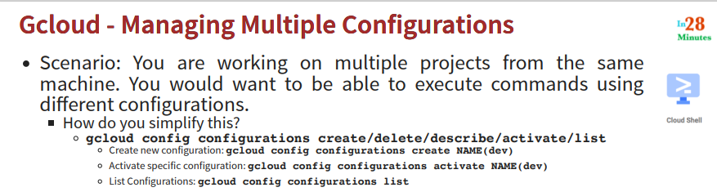

Create a configuration – gcloud config configurations create (one is default – created when cloud shell is launched) – to see all configurations – gcloud config configurations list

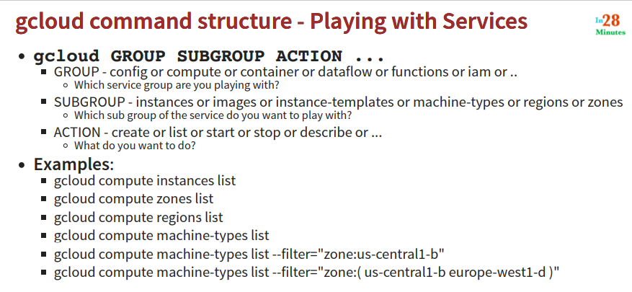

gcloud compute instances create first – this will create new instance with defaults from the default configuration

gcloud compute instance delete – will ask for confirmation

gcloud compute machine-types list --filter zone:us-east1-c

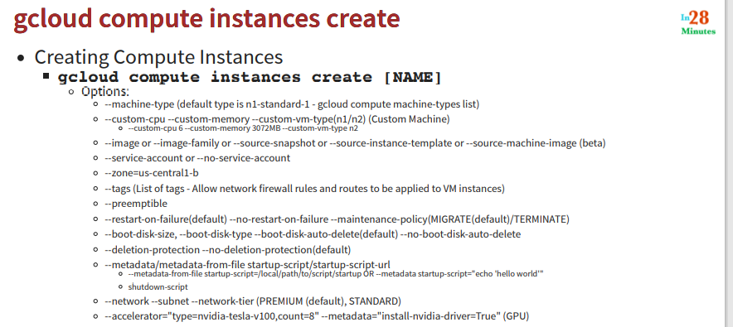

Try different options for - gcloud compute intances create

--metadata – specify path to startup script or specify it there itself, you can also specify shutdown script

Documentation – google – gcloud compute instances create

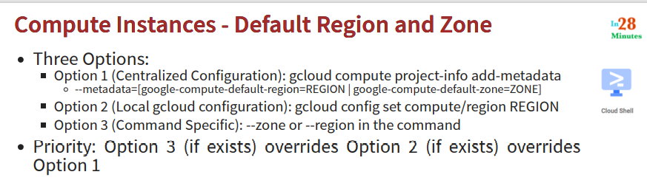

Options to configure default region and zone

Option1 – here you specify the metadata (On UI – Compute Engine > Settings > Settings) – here you set the default region and zone – this is applicable to any user in the current project

Option2 – local setting – this will be applicable for current session only

Option3 – specify in you command – this will be applicable for current command only – this has highest priority

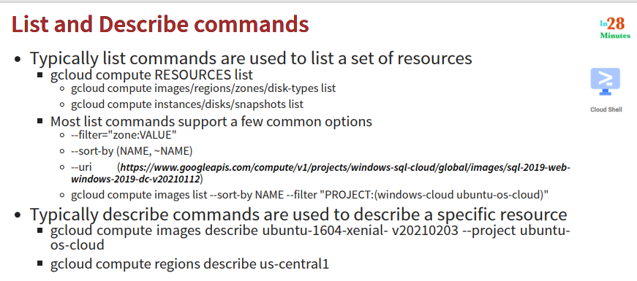

Two types of commands that are very important – list and describe – these have common options:

--filter – to filter down the listing – specified as name:value pair – if you do list, you will see the columns, you can list by any of the column

--sort – sort by certain column – gcloud compute instances list –sort-by STATUS

gcloud compute regions describe us-east1-c

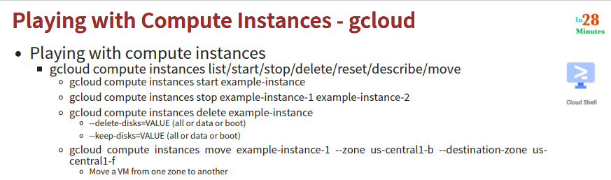

Delete – boot disk, data disk (boot disk – OS associated)

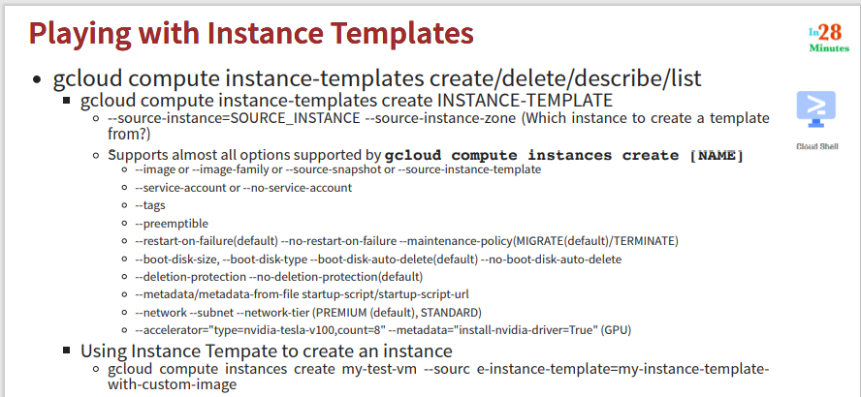

Creating instance template is very similar to creating instances – options are almost similar – any instance created from the instance template has all the configurations set for the instance template

You can create an instance from instance template – from command line

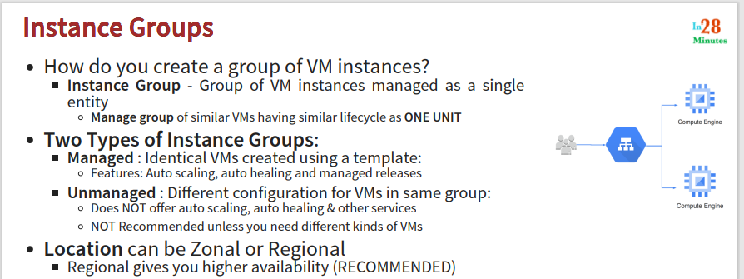

Group of VMs – having similar lifecycle – that we want to manage as single entity (auto healing – configure a health check – if that fails new instance is created)

Autoscaling and auto healing features are available for managed instance groups – useful when you need VMs with same configuration

MIG – Managed Instance Group – can be created using instance templates

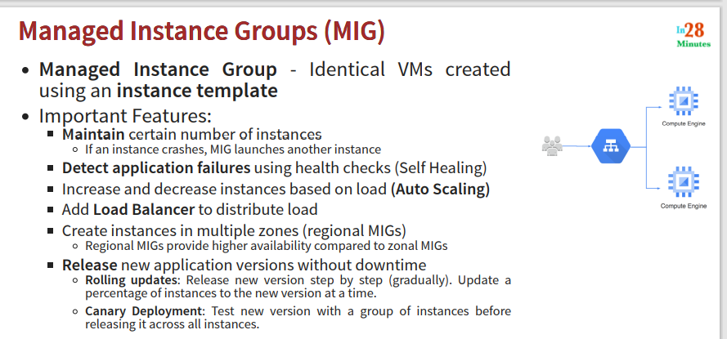

Identical VMs – in MIG

LB can be attached to managed instance groups only – such instances should be created acorss regions – for higher availability

Rolling updates and canary deployment – out of 10 instances, we can choose 2 at a time for update or new version

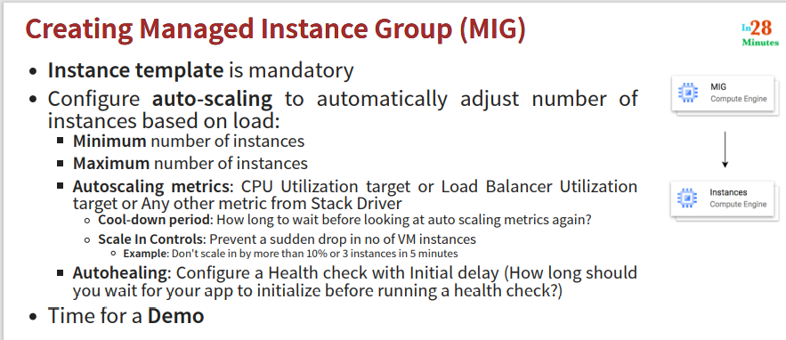

How do you want to do autoscaling – based on CPU utilization etc

Cool-down period – ensures autoscaling and auto downing doesn’t happen very frequently

Settings for auto healing – inhealthy instances are identified – replaced with healthy instances – specify initial delay – configure health check

**Demo**: From an instance template, create VM – instance groups – create new group or group existing instances

Create MIG - If you create an instance group from template – it is managed instance group – select VMs and other options (Network - default) – auto scaling option min and max number of instances – how MIG decides when to autoscale – CPU utilization etc – autoschedule schedule – cool down period – when to chk the metrics again – auto healing

Create health check on our VM – they are performed on periodic basis – logged in cloud log – specify health criteria – every 1 min – every 5 sec etc – timeout – how long to wait before health chk is considered failure – healthy threshold, unhealthy threshold – how many consecutive failure/success to consider VM as healthy/unhealthy

Initial delay

(It will take around 10 min to create MIG group – chk the created instance group)

MIG – stateless and stateful

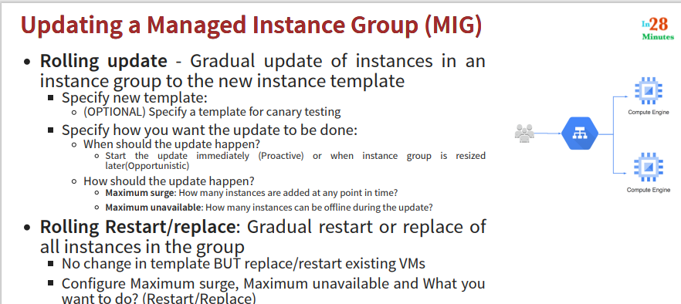

Rolling update – eg you want to update the instance template version – we want to move from old version application to new version application – canary testing – test for few instances and then roll out – specify canary template

Rolling restart – no change in template

Go to MIG – edit – specify new template – specify additional temp instances (max surge)

MIG – to avoid zonal failures – create regional MIG – multi zonal MIG

Incorrect initial delay can result in health check to fail

**Commands executed in next steps**

Here are some of the commands we will execute in the next steps!

1. gcloud compute instances create my-test-vm --source-instance-template=my-instance-template-with-custom-image
2. gcloud compute instance-groups managed list
3. gcloud compute instance-groups managed delete my-managed-instance-group
4. gcloud compute instance-groups managed create my-mig --zone us-central1-a --template my-instance-template-with-custom-image --size 1
5. gcloud compute instance-groups managed set-autoscaling my-mig --max-num-replicas=2 --zone us-central1-a
6. gcloud compute instance-groups managed stop-autoscaling my-mig --zone us-central1-a
7. gcloud compute instance-groups managed resize my-mig --size=1 --zone=us-central1-a
8. gcloud compute instance-groups managed recreate-instances my-mig --instances=my-mig-85fb --zone us-central1-a
9. gcloud compute instance-groups managed delete my-managed-instance-group --region=us-central1

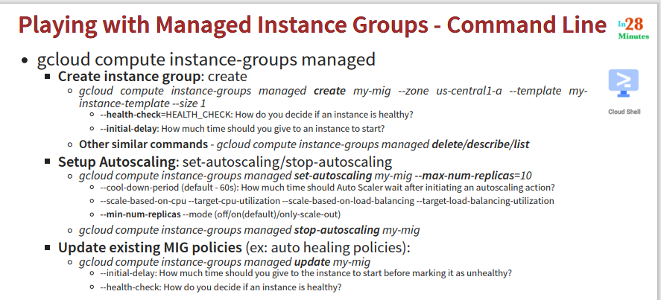

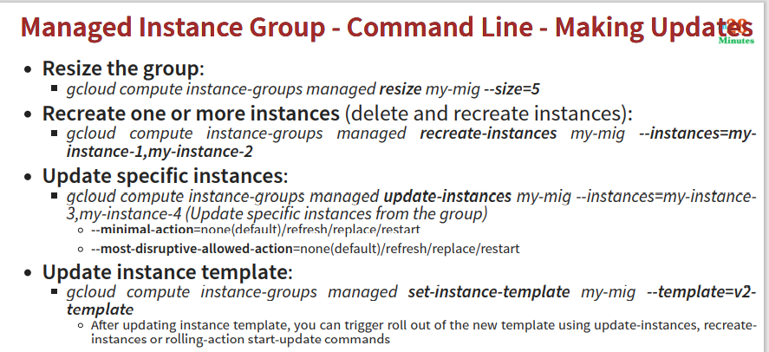

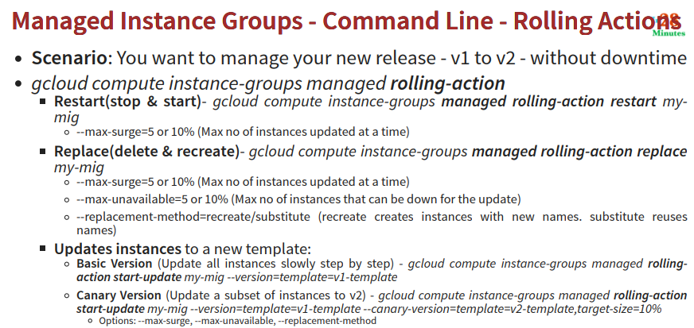

Specify the rolling action – so that there is no downtime during update

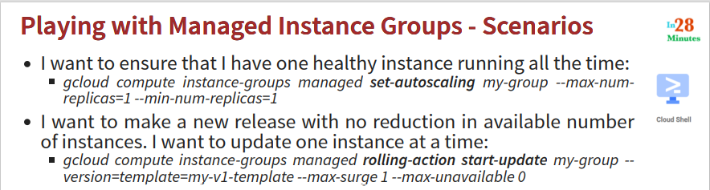

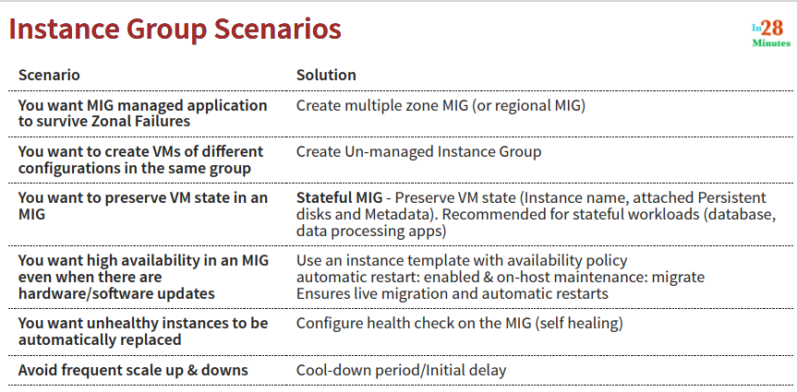

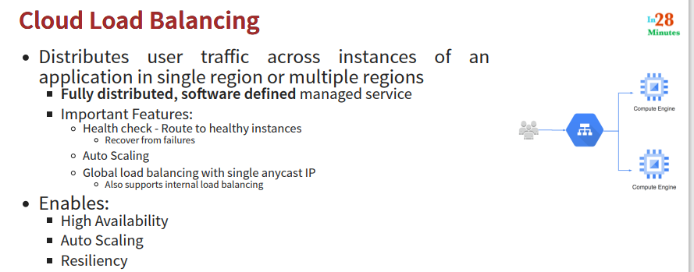

Any LB should have health chk – this way LB can chk if instance is healthy – it will send request to healthy instances – it can send request to instances in multiple regions and zones

LB provides – one IP – can receive global traffic

Internal LB is also supported – within NW

LB send traffic to only healthy instances

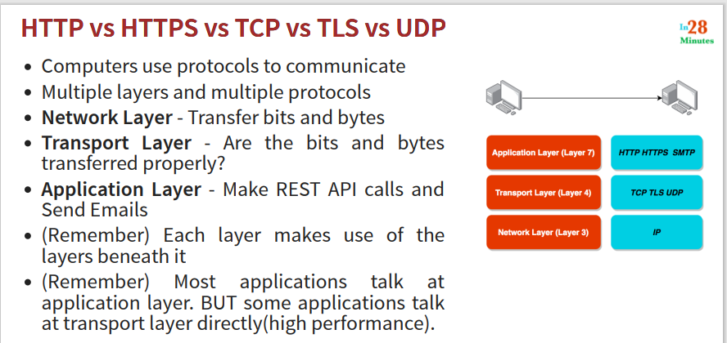

Protocols – needed for communication between two systems – communication happens on multiple layers

Protocol – common language that different systems understand

Most of our applications sit in application layer

For high performance – streaming applications – gaming applications – they can talk directly at transport layer

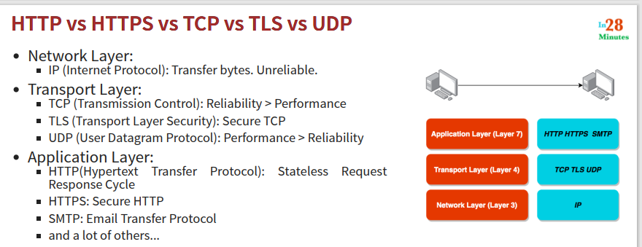

IP protocol is unreliable – hence we need transport layer protocols

Transport layer – confirms sequence of bits and bytes received

In video streaming applications – it is ok if few bytes are lost – UDP is used

HTTP – used for web applications

HTTPS – require certificates – to ensure secure communication

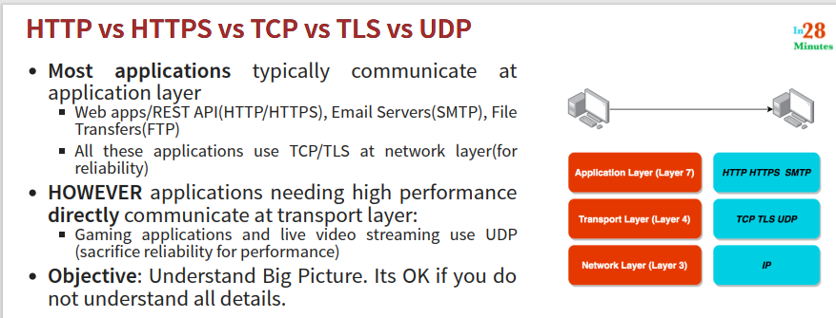

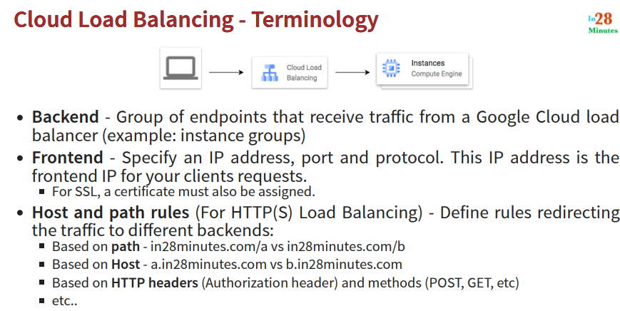

This is part of NW services – create LB

Different types – https, TCP, UDP

You can create either internet facing or internal (within NW)

You cannot have multi region UDP LB

We mostly create http or https LBs – as we deal with web applications

Three things to configure

1. Backend – instance group
2. Host and path rule – how to redirect traffic to backend
3. Front end – provides URL – how user can send the request

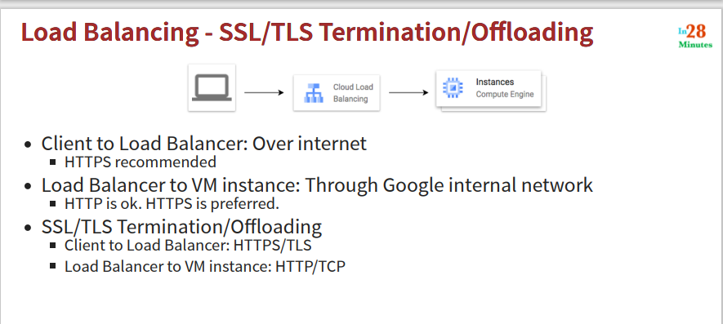

Layer 4 – TLS

Layer 7 – SSL

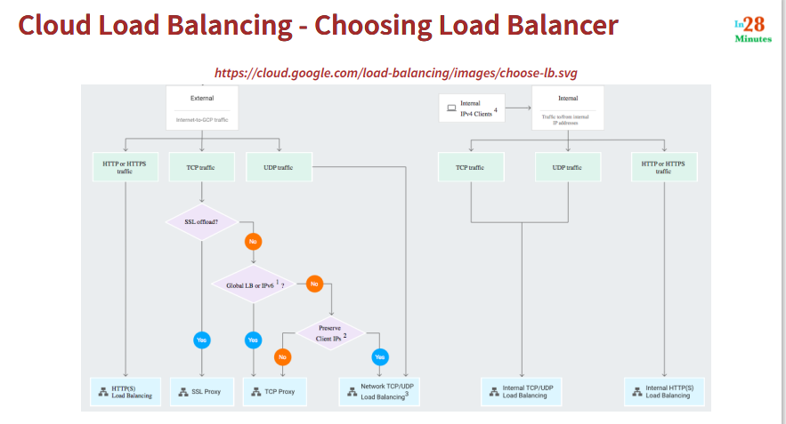

If traffic is internal to NW – internal LB

What is kind of traffic – TCP/UDP/HTTP or HTTPs

If traffic is external – external LB – depending on kind of traffic

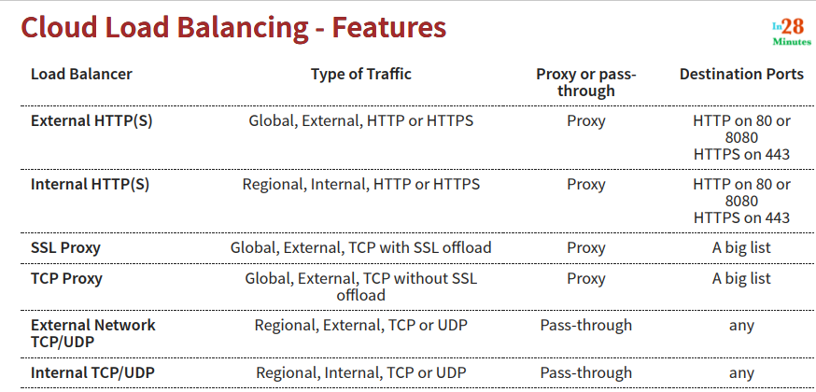

Proxy – receives request from client – makes change – sends further

Pass through – passes as is – backend can see the client request

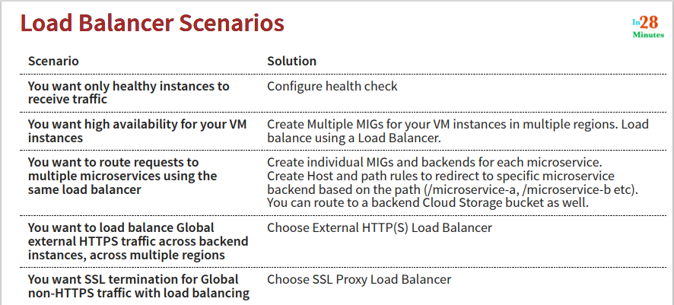

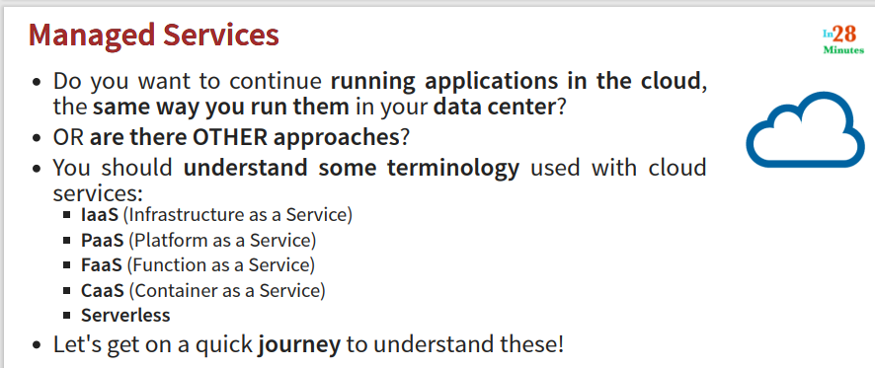

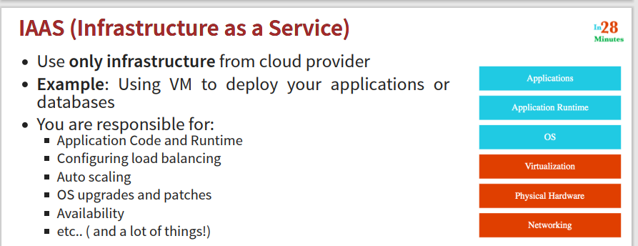

IAAS - Eg: using VM to apply application or data bases

We are responsible for everything above virtualization layer

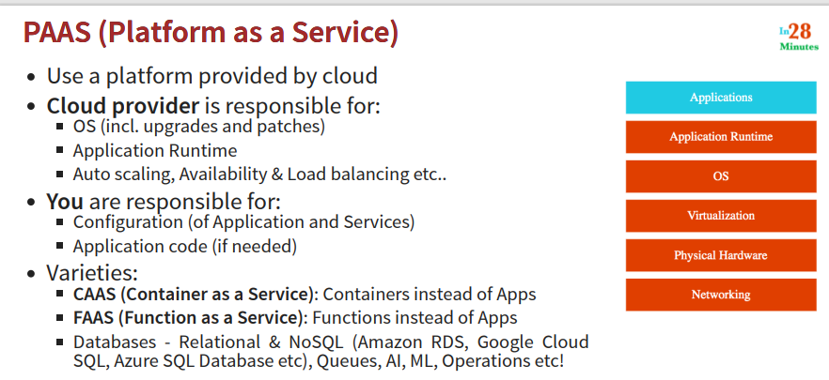

You are responsible for only code

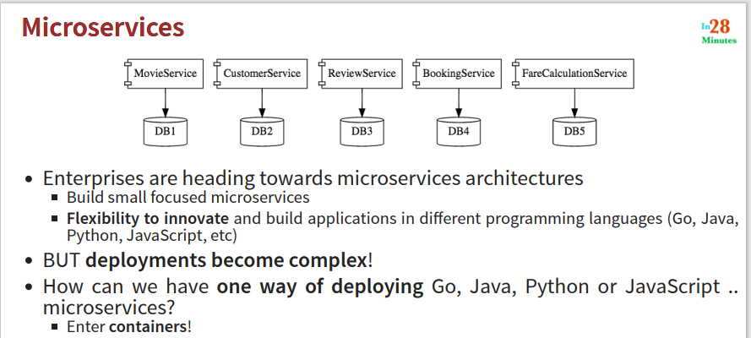

Way you deploy GO application may be different that the way you deploy JAVA

Solution – docker - You create docker images – with each of your microservices

Docker image contains everything needed for running an application – dependencies

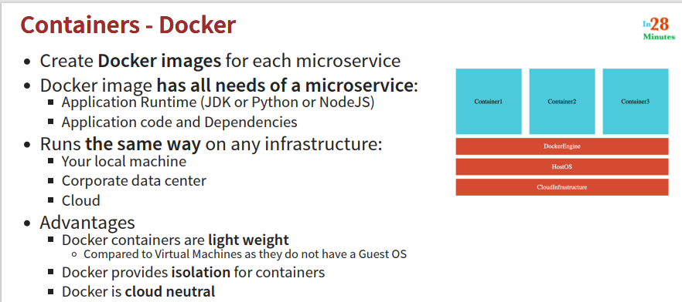

Same docker image used on local -and production – data center – cloud provider

VM has guest OS – docker does not have guest OS

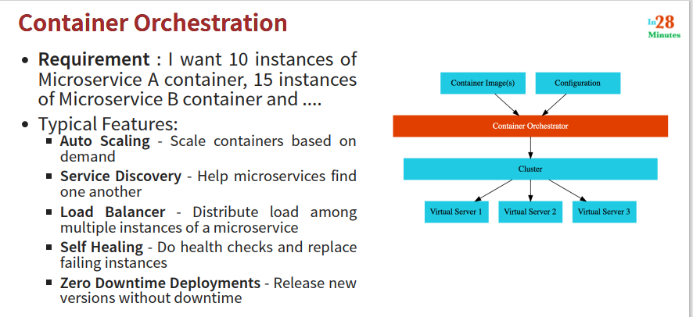

Need orchestration around container

Solution – kubernetes

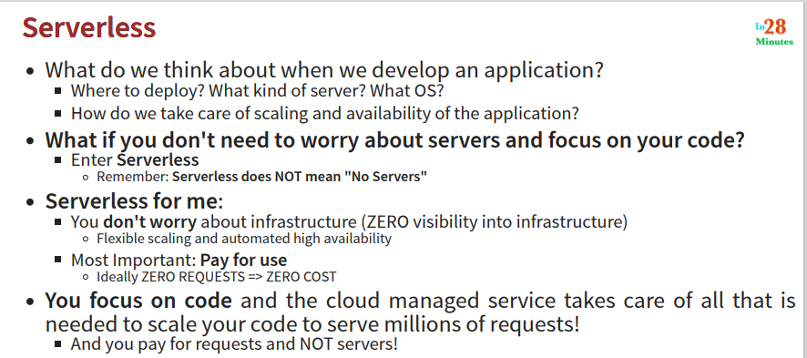

Eg: function as service – lambda

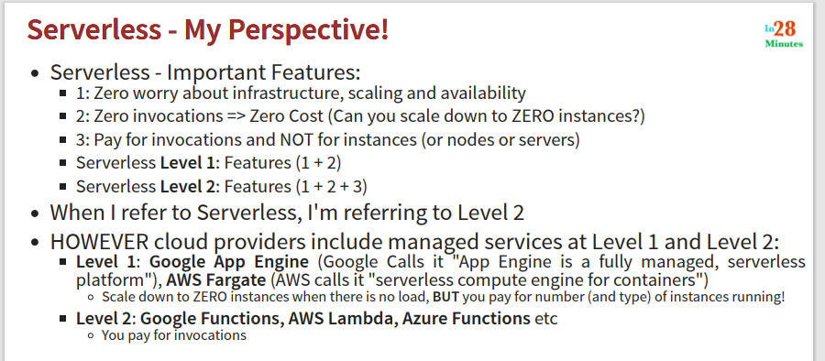

Pay for number of calls to the function

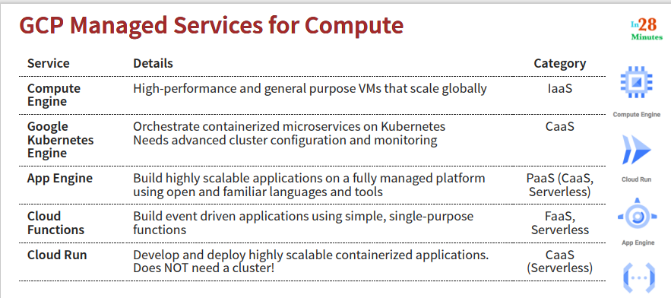

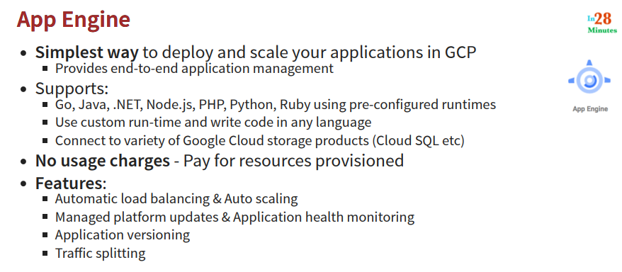

* Most important managed service – introduced in 2008
* Good connectivity with other services that google provides
* Multiple versions of application can be running – and traffic can be split between different versions

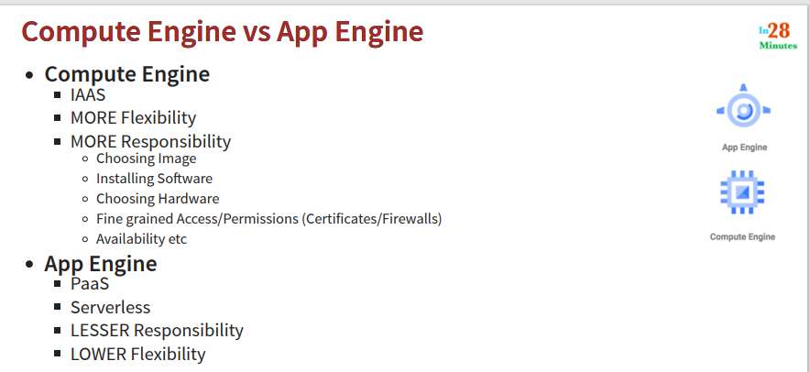

Cannot add GPU for eg, useful for java application, pyton app, GO app

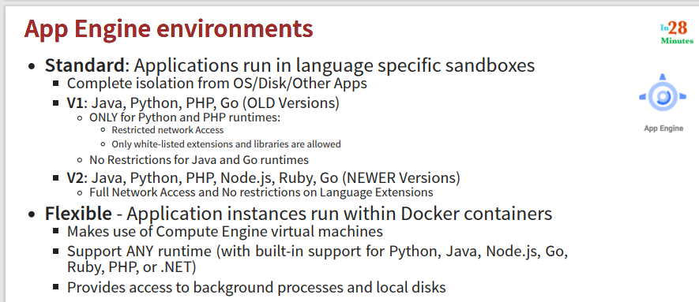

App engines provide language specific sand boxes – pre configured sand boxes – complete isolation – worry only about your code

Standard environment

Flexible environment – your apps are run in docker container

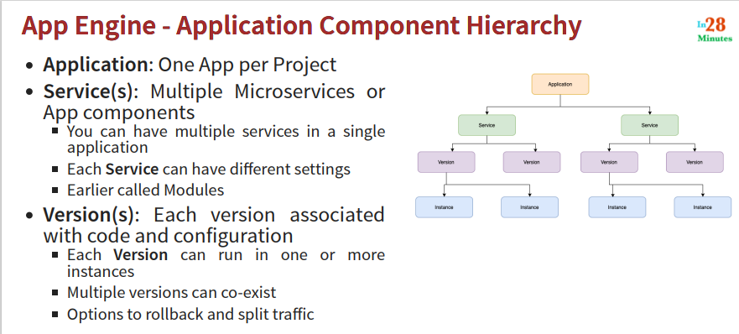

Application – container for everything – one application for one project

Multiple services under one application

Multiple versions of same service can be present

Different environments provided by App Engine

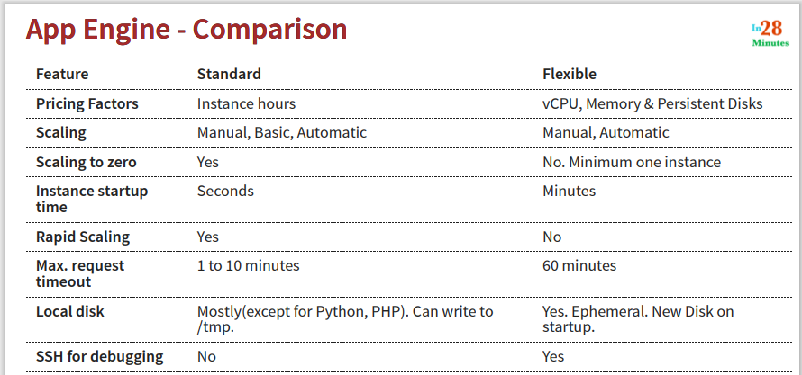

Manual – when you want to have full control

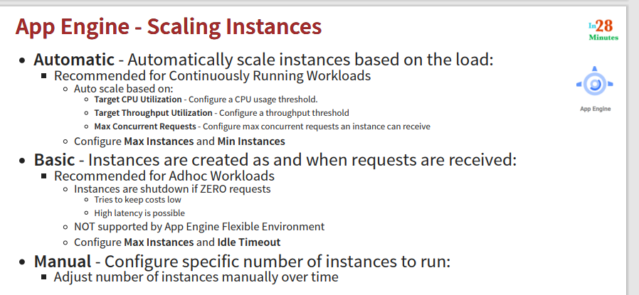

**Commands executed in next steps**

Here are some of the commands we execute in the next steps.

1. cd default-service
2. gcloud app deploy
3. gcloud app services list
4. gcloud app versions list
5. gcloud app instances list
6. gcloud app deploy --version=v2
7. gcloud app versions list
8. gcloud app browse
9. gcloud app browse --version 20210215t072907
10. gcloud app deploy --version=v3 --no-promote
11. gcloud app browse --version v3
12. gcloud app services set-traffic split=v3=.5,v2=.5
13. gcloud app services set-traffic splits=v3=.5,v2=.5
14. watch curl https://melodic-furnace-304906.uc.r.appspot.com/
15. gcloud app services set-traffic --splits=v3=.5,v2=.5 --split-by=random
17. cd ../my-first-service/
18. gcloud app deploy
19. gcloud app browse --service=my-first-service
21. gcloud app services list
22. gcloud app regions list
24. gcloud app browse --service=my-first-service --version=20210215t075851
25. gcloud app browse --version=v2
26. gcloud app open-console --version=v2
27. gcloud app versions list --hide-no-traffic

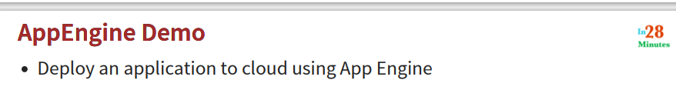

Create a new project – learning app engine project (there is a limit on number of projects - 21)

Search App Engine

Enable APIs for this service – App Engine Admin API (not enabled by default)

Create a new app engine application – choose region – in one project you can have only one application

Choose language (default - python) – environment – standard

Deploy service to app engine – Cloud Shell (editor) – code editor will open

Open folder – copy the files (in zip app-engine) (try ls in shell)

App.yml – configuration for app engine

Main.py – python code

Requirements – we are defining dependencies of this application (python framework – flask is defined here – python framework for web applications)

Go to the folder location - gcloud app deploy (ensure correct project is set)

(IAM – permissions for ppl and services)

Whenever we deploy anything on app engine - Deployment package is created – using CICD – cloud build – this is uploaded to google cloud storage – cloud build needs access to google cloud storage (give the required permission) – give access to cloud bill service account

You will get the URL – hit it

In App engine – explore different options – services – versions – instances

You can get all this information on command line also

Gcloud app services list

